Blood Bank Management
System Project

First Sprint Backlog & Status

Product Backlog
- User Management:
  - User registration for admin, donor, hospital, and organization (done)
  - User login and authentication (yet to be done)
  - Role-based access control (in progres)
- Inventory Management:
  - Inventory schema definition (done)
  - Inventory CRUD operations (done)
  - Search and filter functionality for inventory (in progress)
- Donation Management:
  - Scheduling and managing blood donations
  - Tracking donation history
- Reporting and Analytics:
  - Generate reports for blood inventory
  - Dashboard for user activities and inventory status
- Testing and Deployment:
  - Unit and integration testing
  - Continuous deployment and integration setup

Status Update for Sprint 1
- Connected to MongoDB database: Completed
- Defined user schema: Completed
- Defined inventory schema: Completed
- Created frontend registration for admin: Completed
- Created frontend registration for donor: Completed
- Created frontend registration for hospital: Completed
- Created frontend registration for organization: Completed
- Develop backend logic for inventory management (CRUD operations) Completed
- Develop backend logic for user management (CRUD operations) Completed
- Implement JWT (JSON Web Token) authentication Completed
- Set up authentication routes on the backend Completed
Live recording of Working software status
Connection to MongoDb database
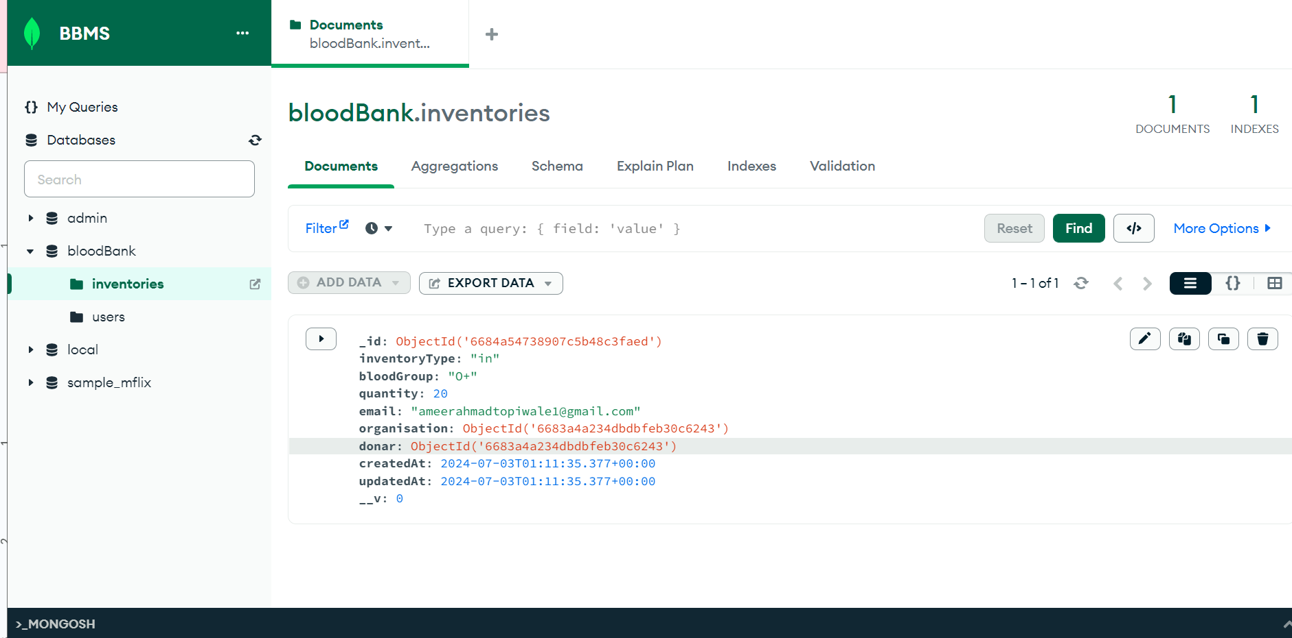
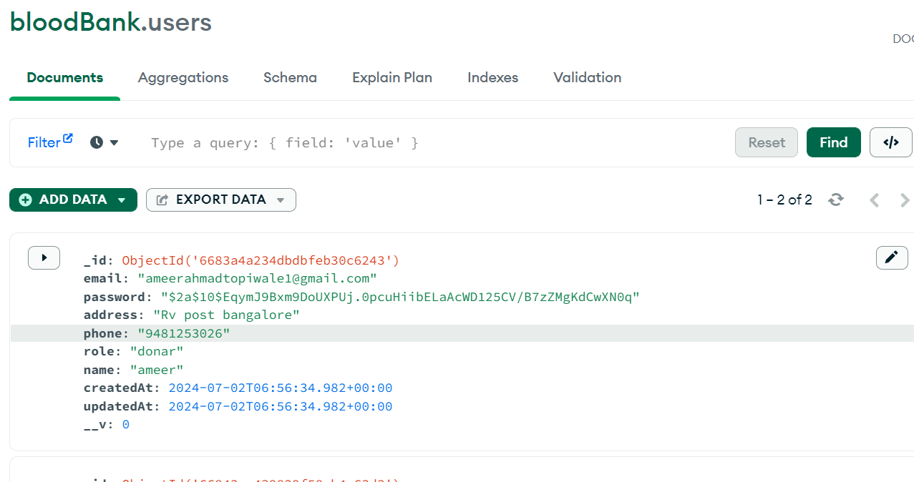





2nd Sprint Backlog items

Sprint 2 Backlog

User Login and Authentication:
- Create login page for all user types (admin, donor, hospital, organization)
- Validate user credentials on login
- Handle login errors and display appropriate messages
- Store JWT token in the client-side securely (e.g., localStorage or cookies)
User Logout and Authentication:
- Implement logout functionality on the frontend
- Invalidate JWT token on logout
- Redirect users to the login page upon logout
- Ensure secure token storage and invalidation

Frontend for Inventory Management:
- Create inventory dashboard for viewing inventory status
- Implement inventory list view with search and filter options
- Develop forms for adding new inventory items
- Develop forms for updating existing inventory items
- Implement delete functionality for inventory items

Role-Based Access Control:
- Define roles and permissions for different user types (admin, donor, hospital, organization)
- Implement middleware on the backend to check user roles and permissions
- Restrict access to certain routes based on user roles
- Display different UI elements based on user roles (e.g., admin sees more options than a donor)
- Test access control to ensure correct permissions for each user type

--------------------------------------------------------------------------------

